Senior Project Report: Mixed Reality Experience


Exploring Maladaptive Daydreaming and Capitalist Alienation through VR
Author: Semiha PAKSOY
Course: MUS441 - Senior Project I
Academic Year: 2025-2026
Date: January 1, 2026

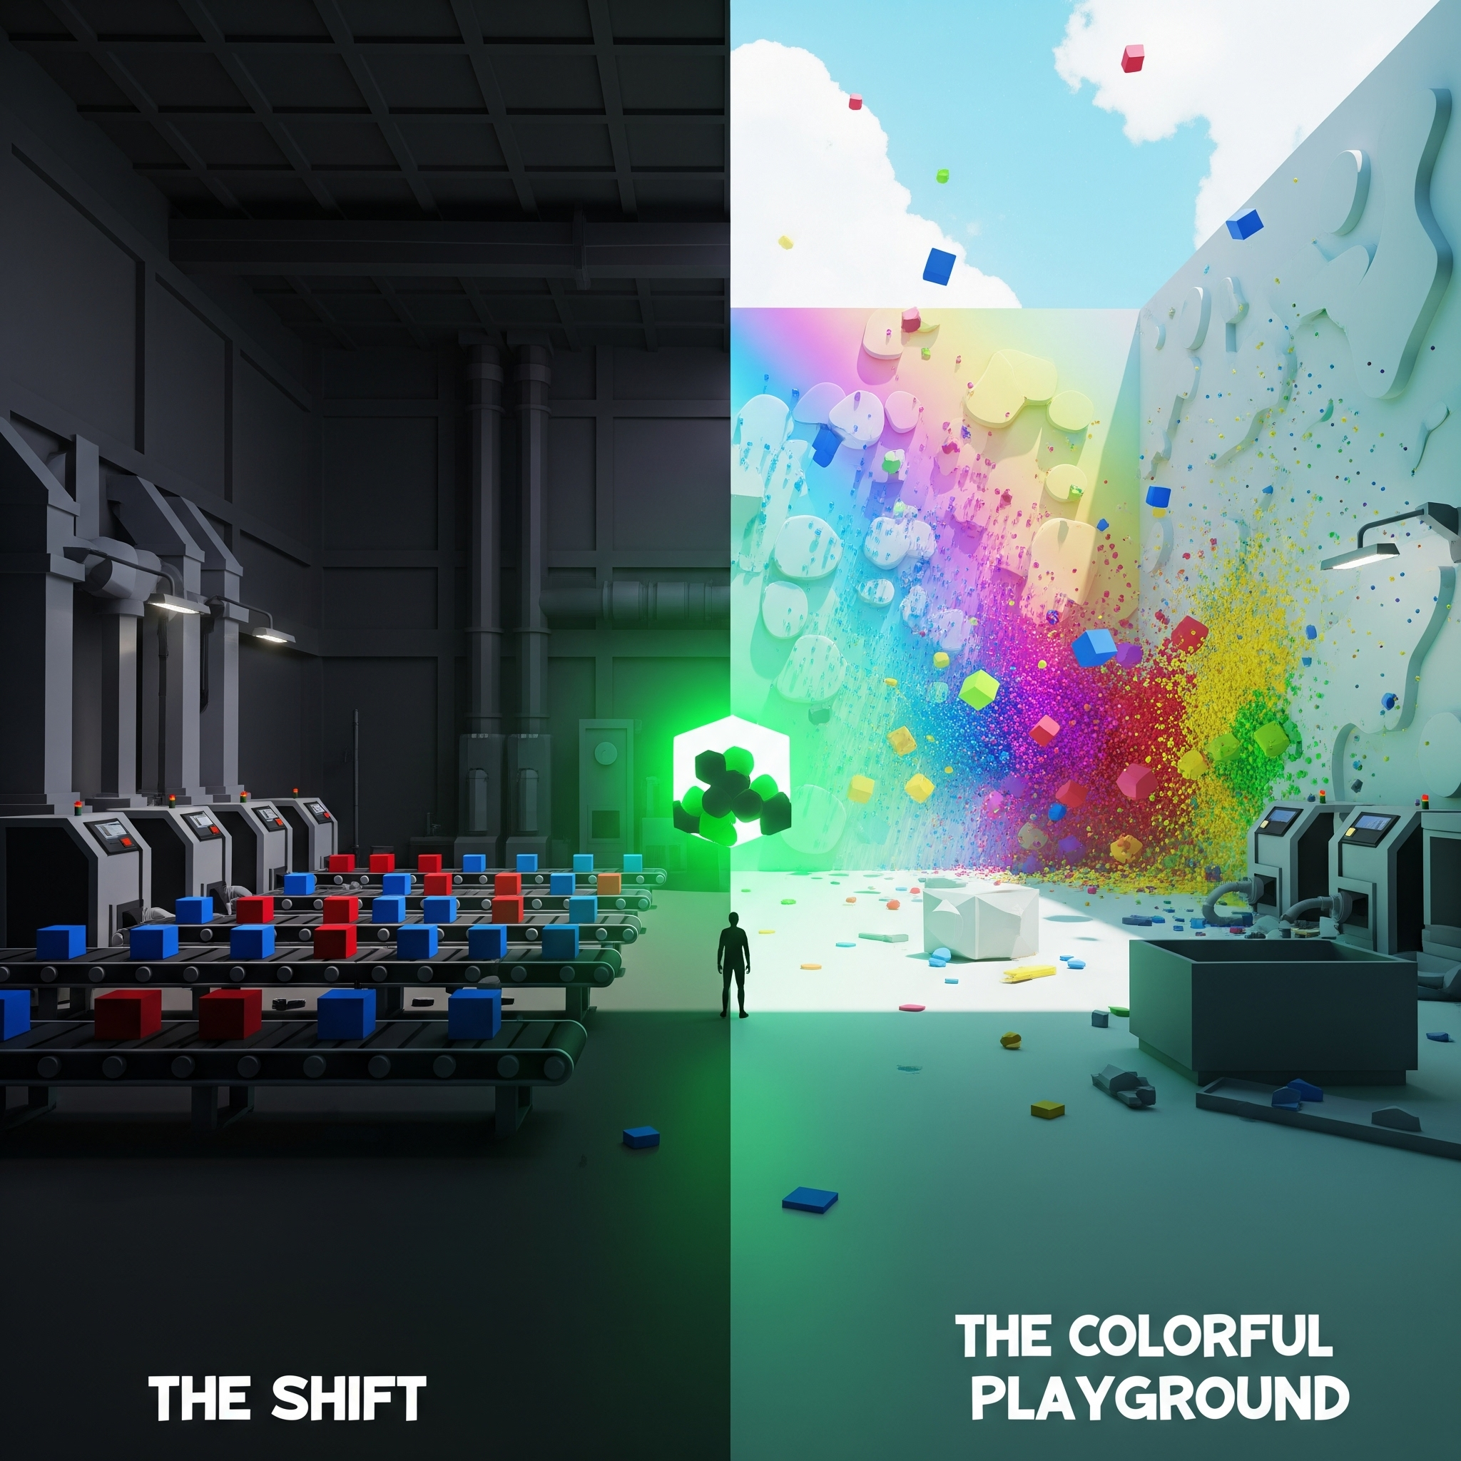

The story and flow of the scenario are available on the Presentation Board.

GitHub Link for the Project: https://github.com/smhpk-1/mixedreality-graduation-project/tree/dee6e034581ffd4e5f9e2b31939516f82e08b6e2

1. Abstract
This senior project presents a Mixed Reality (MR) experience designed for the Meta Quest 3S, exploring the complex psychological phenomenon of maladaptive daydreaming and its relationship to capitalist alienation. The project leverages the immersive capabilities of Virtual Reality (VR) to create a bifurcated narrative experience that physically transports the user from a monotonous, oppressive industrial setting to a boundless, surreal playground. By juxtaposing these two distinct environments—"The Shift" and "The Colorful Playground"—the project critiques the rigidity of modern labor systems while celebrating the liberating, albeit isolating, power of human imagination. This report details the conceptual framework, technical implementation, creative process, and the specific design decisions made to translate abstract psychological theories into a tangible, interactive reality.

2. Introduction

2.1 Purpose & Vision
The primary purpose of this project is to utilize Virtual Reality as a medium to simulate and explore the internal experience of maladaptive daydreaming. Unlike traditional media, VR offers a sense of presence, allowing users to inhabit the perspective of a worker caught between the crushing weight of external societal constraints and the vivid allure of internal creative freedom.

The vision is to create a dynamic virtual environment where users interact with objects and systems using advanced hand tracking and controllers. The project aims to explore advanced user interaction paradigms, procedural content generation, and real-time feedback in a VR/MR context.

2.2 Motivation
Modern capitalist societies often foster feelings of alienation and monotony, particularly within industrial or repetitive work environments. For many individuals, daydreaming serves not just as a distraction, but as a critical coping mechanism—a form of psychological resistance to reclaim agency in a world that demands conformity. This project seeks to visualize this psychological escape, using VR technology to blur the lines between "reality" (the factory) and "fantasy" (the playground), making the internal struggle external and visible.

2.3 Problem Statement
How can immersive technology be used to represent abstract psychological concepts like alienation, dissociation, and escapism? Traditional storytelling can describe these states, but VR can induce them. This project addresses this challenge by creating a spatial narrative that physically transports the user from a restrictive, rule-bound environment to one of limitless possibility, forcing them to experience the jarring transition between these two states of being.

3. Conceptual & Theoretical Framework

3.1 Maladaptive Daydreaming
Maladaptive daydreaming is a psychological concept describing extensive fantasy activity that replaces human interaction and/or interferes with academic, interpersonal, or vocational functioning. Individuals experiencing maladaptive daydreaming often become deeply absorbed in vivid, elaborate inner worlds, sometimes as a coping mechanism for stress, trauma, or dissatisfaction with reality.

- Key Characteristics: Intense, immersive, narrative-driven daydreams; difficulty controlling the urge to daydream; use of daydreaming as an escape from real-world problems.
- Relevance to VR: VR serves as a technological extension of the mind’s capacity for immersive fantasy, providing a controlled, interactive space for users to explore alternate realities. The project leverages this parallel, intentionally blurring the line between healthy escapism and maladaptive detachment.

3.2 Capitalism, Alienation, and Escapism
Drawing from Marxist theory, the project explores the concept of alienation—the detachment of workers from the products of their labor, from the act of production, and from their own humanity.

The Factory as Metaphor: The industrial setting represents the capitalist machine. The user is reduced to a function (sorting cubes), governed by rigid quotas and the symbolic presence of time. Time does not operate as a gameplay mechanic, but as an atmospheric tool that reinforces pressure, surveillance, and monotony. The labor is repetitive, meaningless, and isolating.

Escapism as Resistance: The transition to the surreal world represents the mind’s attempt to escape rigid and repetitive systems. Instead of continuing a meaningless task, the user enters a space where actions are not judged by productivity, but by freedom and play.

3.3 Surrealism and the Subconscious
The project adopts a surrealist aesthetic to represent the inner world. This aesthetic aims to create a dreamlike and fluid experience that partially departs from the rigid logic of the real world. By deliberately stretching physical and visual expectations—through color-reactive walls, anomalous objects, and unconventional interactions—the experience reflects the fluid and ever-changing nature of the subconscious mind.

4. Project Narrative & Design
The experience is structured into two contrasting scenes, representing the duality of the protagonist's mind.

4.1 Scene 1: The Shift (The Reality)
Narrative Overview
"The Shift" is an industrial prologue representing the monotony and alienation of the capitalist system. The player is cast as a "worker," isolated from the outside world in a dim, oppressive factory where time is tracked only by a mechanical wall clock.

Mechanics & Interaction

- The Routine: Red and blue cubes are spawned from wall-mounted dispensers and move along a conveyor belt. The user must grab and sort them into matching bins using the Meta Quest 3S controllers.

The Quota: The user is tasked with sorting 30 cubes as part of the repetitive routine. After this phase, glowing green anomaly cubes appear. Grabbing one of these anomaly cubes triggers the transition to the second scene.

Symbolism

- Industrial Monotony: The dark, oppressive factory represents capitalist alienation.
- Routine & Alienation: The act of sorting mirrors the lack of agency in industrial labor.
The Anomaly: The glowing green cubes represent a disruption of the established system. In an environment built around red and blue cubes and their corresponding bins, the appearance of green cubes that cannot be placed into any bin reveals the system’s limitations and suggests the possibility of stepping outside its rules.

Key Scripts

- GameManager.cs, ObjectSpawner.cs, ConveyorBelt.cs, BinCollector.cs, DispenserGenerator.cs, FactoryScoreBoard.cs, WallClock.cs, AnomalyCube.cs.

4.2 Scene 2: The Colorful Playground (The Escape)
Narrative Overview After leaving the factory environment, the player enters The Colorful Playground—a surreal space that reflects the logic of maladaptive daydreaming. This scene presents a recontextualization of familiar objects. The same cube-based interactions are reworked with new meanings and functions: cubes become colorful, playful, and capable of producing sound, allowing the user to engage with them through exploration and play rather than labor.

Mechanics & Interaction

- Creative Freedom: The room contains 20 colorful cubes (Red, Blue, Green, Yellow, Purple) scattered across the floor.
- Reactive Environment: Throwing a cube at a wall triggers the ColorReactiveWall script, painting the wall with that color. This allows the user to reshape their environment dynamically.

Physics & Play: Unlike the rigid sorting mechanics of Scene 1, this scene allows objects to be freely thrown and to react to surfaces through collision. There are no quotas, rules, or predefined goals guiding the interaction.

Symbolism

- 20 Colorful Cubes: Represent fragments of creativity suppressed by the factory.
- Reactive Walls: Represent the malleability of reality within the imagination.
- Throwing vs. Sorting: Throwing represents creative expression and release, contrasting with the careful sorting of Scene 1.
- No Quotas: The absence of objectives critiques the productivity-obsessed nature of capitalism.

Thematic Contrast

Scene 1: The Shift | Scene 2: The Playground
Dark, oppressive | Bright, liberating
Rules and quotas | Freedom and creativity
Sorting (conformity) | Throwing (expression)
Fixed environment | Reactive, changeable
Monotone colors | Vibrant spectrum

Key Scripts

- Scene2RoomGenerator.cs, Scene2TwentyColoredCubesGenerator.cs, ColorReactiveWall.cs, PlaygroundCube.cs.

5. Technical Implementation

5.1 Platform & Tools
- Device: Meta Quest 3S (Android)
- Engine: Unity 6 (6000.2.10f1)
- Frameworks: OpenXR, XR Interaction Toolkit, Unity Input System
- Language: C#
- Version Control: Git

5.2 Key Systems & Architecture

5.2.1 XR Interaction System
The project utilizes the XR Interaction Toolkit for robust hand tracking and controller support. Custom configurations on XRGrabInteractable allow for precise manipulation of cubes. Physics are tuned for realistic weight and collision response.

5.2.2 Procedural Generation
To ensure replayability and a sense of scale, much of the world is generated procedurally at runtime.

- Factory: FactoryFloorGenerator.cs and MachineGenerator.cs construct the industrial environment.
- Playground: Scene2RoomGenerator.cs builds the reactive room, while Scene2TwentyColoredCubesGenerator.cs handles the distribution of interactive cubes.

5.2.3 Dynamic Environment Logic
- Reactive Walls: The ColorReactiveWall.cs script detects collisions and applies the material color of the colliding object to the wall mesh.
- Game Management: A central GameManager.cs orchestrates the state flow, tracking the sorting quota and triggering scene transitions.

5.2.4 Audio Immersion
- Spatial Audio: Sounds are spatialized to ground the user.
Procedural Audio: Impact sounds are dynamically generated and modulated by collision velocity through CubeCollisionSound.cs, while CubeGrabAudio.cs provides audio feedback when objects are grabbed.
- Atmosphere: RuntimeAtmosphereController.cs manages the visual atmosphere (lighting, fog) to create the oppressive factory mood.

5.2.5 Optimization
- Lighting: LightingOptimizer.cs manages real-time vs. baked lighting.
- Asset Management: Efficient use of prefabs and object pooling prevents garbage collection spikes.

5.3 Folder Structure
- Assets/: Main project assets (Materials, Prefabs, Scenes, Scripts, Resources).
- Library/: Unity-generated cache.
- Packages/: Unity package manifest.
- ProjectSettings/: Unity project settings.

6. Development Process

Phase 1: Project Setup & Prototyping
- Repository initialization and XR configuration (OpenXR, XR Interaction Toolkit).
- Prototyping core XR mechanics: grabbing, throwing, and collision detection.
- The "sorting" mechanic was built first to establish the baseline interaction.

Phase 2: Environment & Tools
- Developed procedural scene generation scripts for rapid prototyping.
- Created distinct visual identities: low-poly industrial assets for the factory, high-contrast vibrant materials for the playground.
- Implemented custom editor tools for batch asset creation.

Phase 3: Scripting & Logic
- Implemented the core logic for "The Shift," connecting BinCollector to GameManager to track the 30-cube quota.
- Developed the AnomalyAssetGenerator and transition logic.
- Implemented the reactive wall system for Scene 2.

Phase 4: Polish & Optimization
- Performance tuning for Quest 3S (profiling, reducing draw calls).
- Visual and audio polish: Haptic feedback, spatial audio, and baked lighting.
- Deployed APK to device for real-world testing and iteration.

7. Outcome & Conclusion

7.1 Current Status
The project successfully implements the complete narrative arc. Users can experience the transition from the monotonous sorting task to the liberating creative playground. The application runs stably on the Meta Quest 3S with functional hand tracking and physics.

7.2 Reflection
The project demonstrates the potential of VR to convey complex psychological and sociological themes. By placing the user physically inside the metaphor, the abstract concepts of "alienation" and "freedom" become tangible, felt experiences. The contrast between the two scenes effectively communicates the relief and joy of the daydreaming state.

7.3 Future Work
- Expanded Narrative: Further developing the narrative depth to enhance the psychological contrast between the two worlds.

8. References
- Somer, E. (2002). Maladaptive Daydreaming: A Qualitative Inquiry. Journal of Contemporary Psychotherapy.
- Marx, K. (1844). Economic and Philosophic Manuscripts.
- Breton, A. (1924). Manifesto of Surrealism.
- Unity Technologies. (2024). Unity Documentation.
- Meta. (2024). Meta Quest Developer Documentation.
- Radiohead, & Universal Music Group. (2021). Kid A Mnesia Exhibition [Interactive Experience].

